Experiment 12: Write a python program to implement the Tic Tac Toe Game

Aim
To write a Python program to implement the Tic Tac Toe Game.

Algorithm
- Create a 3×3 game board.
- Initialize all positions as empty.
- Allow two players (X and O) to make alternate moves.
- Update the board after each move.
- Check for a winning row, column, or diagonal.
- If a player wins, display the winner.
- If all cells are filled without a winner, declare the game as a draw.

Program
board = [' ' for i in range(9)]

def print_board():
print(board[0], "|", board[1], "|", board[2])
print("--+---+--")
print(board[3], "|", board[4], "|", board[5])
print("--+---+--")
print(board[6], "|", board[7], "|", board[8])

def check_win(player):
wins = [
[0,1,2], [3,4,5], [6,7,8],
[0,3,6], [1,4,7], [2,5,8],
[0,4,8], [2,4,6]
]

for w in wins:
if board[w[0]] == board[w[1]] == board[w[2]] == player:
return True
return False

moves = [(0,'X'), (3,'O'), (1,'X'), (4,'O'), (2,'X')]

for pos, player in moves:
board[pos] = player

print_board()

if check_win('X'):
print("Winner: X")
elif check_win('O'):
print("Winner: O")
else:
print("Draw")

Output
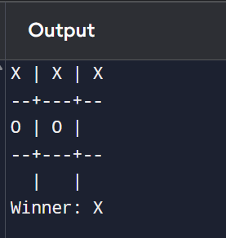

Result
Thus, the Python program to implement the Tic Tac Toe Game was executed successfully, and the winner was displayed correctly.

